Geometry: Unit 1, Lesson 11
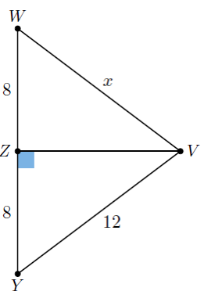
- In the figure shown, $\overline{VZ}$ is the perpendicular bisector of $\overline{WY}$, where $WZ=8$, $YZ=8$, and $VY=12$. What is the length of $\overline{VW}$?

12

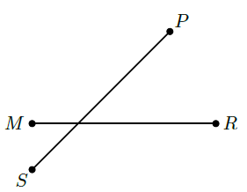
- Is the image shown a perpendicular bisector?

No

- What contains at least two equal length sides and two equal interior angle measures?

Isosceles Triangle

